Application to Depasture Cattle and Horses on Commons

Use this form to apply for a permit to apply for agistment on Town Commons.
For full conditions and eligibility criteria, please see Guidelines to Depasture Cattle and Horses on Commons.
Barcaldine Regional Council states that Council will comply with the Information Privacy Act 2009 (Qld) (IP Act)

Applicant Details
Surname |  | Given Name
Postal Address
Physical Address
Daytime Contact Number |  | Mobile Phone Number

Agistment Details
I hereby make application to agist stock on the Town Common of: |  |  |  | Application type
 |  |  |  | New application Renewal
 | Alpha | Maximum of 20 head of cattle/horses per household
 | Aramac | Maximum of 20 head of cattle and 5 head of horses per household
 | Barcaldine | Maximum of 8 head of cattle/horses per household
 | Jericho | Maximum of 20 head of cattle/horses per household
 | Muttaburra | Maximum of 30 head of cattle and 5 head of horses per household

Eligibility (Please answer all of the below)
I am the bona-fide owner of all stock for which depasturage is sought. |  | Yes |  | No
I have resided in the town or on a rural/rural residential allotment of less than 15ha, closest to the town common I desire to agist stock on, for a period of greater than 1 year continuously prior to the date of application, and I am enrolled on the state electoral roll for the town in which I reside. |  | Yes |  | No
I am a permanent resident of that town and will advise the Chief Executive Officer in writing within 7 days of a change to my residency status. |  | Yes |  | No
I will advise the Chief Executive Officer in writing within 7 days of any changes to my circumstances in relation to this application. |  | Yes |  | No
I, or my associated entity, own or lease less than 15ha for the purpose of depasturing stock. |  | Yes |  | No
I have no other stock or less than 31 head of cattle and/or horses on agistment elsewhere. |  | Yes |  | No
I do not have any outstanding fees and charges owing to Barcaldine Regional Council. |  | Yes |  | No
All cattle are clearly branded with a brand registered in my name, and I have supplied a copy of my brand certificate to Barcaldine Regional Council (not applicable to horse owners). |  | Yes |  | No
I understand that stallions and rigs are not permitted on any town common. |  | Yes |  | No
I understand that bulls may be permitted as determined by the Chief Executive Officer or the relevant Management Committee. |  | Yes |  | No
I understand that no stock is to be depastured until I have received a permit from Barcaldine Regional Council. |  | Yes |  | No
I have received and will abide by the Guidelines to Depasture Cattle and Horses on Commons. |  | Yes |  | No
I take responsibility for payment of all agistment fees for the approved stock. |  | Yes |  | No
If you have answered ‘No’ to any of these questions, you are not eligible to agist stock on the town common.
Details of Stock
Number of cows |  |  | Calves |  | Horses |  | 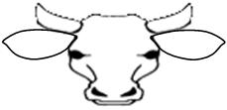 | 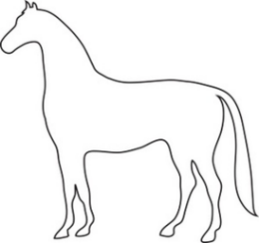
Your registered brand
Your earmark
Your ear tag
Horse/s Colour or significant markings |  |  |  |  |  |  | 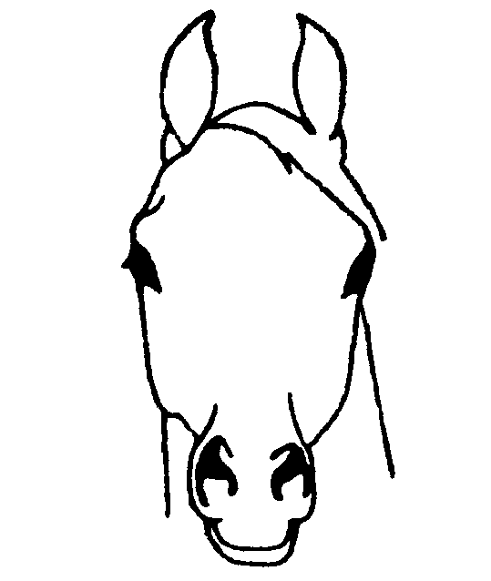

Declaration
I, |  | do solemnly and sincerely declare that all details given and
statements made in connection with this application are true and correct.
And I make this solemn declaration conscientiously believing the same to be true, and by the virtue of the provisions of the Oath Act 1867.
Signature of Applicant (to be signed in front of Justice of the Peace / Commissioner of Declarations) |  |  |  |  | Date
Taken and declared before me at |  |  | Seal and Registration Number
On this day
Signature of Justice of the Peace / Commissioner for Declarations

Application Fees for 2023/ 2024 Financial Year
Agistment | Cattle - Total Agistment Fees ($4.00 per week per head) | $
 | Horses - Total Agistment Fees ($6.00 per week per head) | $
Bull Levy | Total Bull Levy (if applicable) ($32.00 per annum per head) | $

Lodgement of your application
MAIL | Post to ‘PO Box 191, Barcaldine QLD 4725’  Cheques or money orders to be made payable to “Barcaldine Regional Council”
IN PERSON |  | Visit any BRC Administration Office from 8.00am to 4.30pm Monday to Friday with cash, cheque or EFTPOS | Alpha  Aramac  Barcaldine | 43 Dryden Street  35 Gordon Street  71 Ash Street

OFFICE USE ONLY
Payment for (months) | 3 6 12 | Receipt No. |  | Date paid to | / /

RLO USE ONLY
Total cattle on common |  | Total horses on Common |  |  |  | Date
Cattle currently on common owned by customer |  |  |  | Horses currently on common owned by customer

DISTRICT MANAGER APPROVAL
I approve the application by |  |  |  |  |  |  |  |  |  | on the |  |  | Town Common
to depasture |  |  |  |  | head of cattle and/or |  |  |  | horses
 |  |  |  |  | head of cattle and horses
Name |  |  |  |  |  | Signed |  |  |  |  |  | Date

Guidelines to Depasture Cattle and Horses on Commons

The attached Eligibility Guidelines, Management Guidelines and Operational Guidelines are as amended by Council on 21 July 2010.

MANAGEMENT GUIDELINES
- Each community should establish a Town Common Management Committee consisting of common stock owners. Any additional guidelines determined by the Management Committee must be approved by the Chief Executive Officer.
- The maximum number of stock that may be depastured by each applicant shall be determined by the Council from time to time but at no time shall exceed the maximum carrying capacity of each common.
- The maximum carrying capacity of each common is as follows:
Alpha: 130 head
Aramac: 467 head
Barcaldine: 240 head
Jericho: 302 head
Muttaburra: 378 head
- The maximum stocking rate as at the date of the approval of this Policy is:
Alpha: 20 Head of Cattle/Horses per Household
Aramac: 20 Head of Cattle and 5 Head of Horses per Household
Barcaldine: 8 Head of Cattle/Horses per Household
Jericho: 20 Head of Cattle/Horses per Household
Muttaburra: 30 Head of Cattle and 5 Head of Horses per Household
The condition of the commons will be reviewed half yearly and stocking rates will be amended accordingly.
- Stock shall become eligible for a permit upon reaching the age of six (6) months. The Rural Lands Officer or a representative appointed by the Chief Executive Officer will be the sole judge in this instance and their determination of the ages will be final.
- Steers are to be removed from the town common at each muster, when, in the opinion of the Rural Lands Officer, such stock has reached the age of twelve (12) months.
- All pound fees together with depasturage fees shall be payable in respect to stock seized on the abovementioned lands for which no permit has been approved.
- By notice in writing the Council reserves the right to refuse an application for a permit or cancel any current permit including for non-payment of overdue debts to Council.
- The Rural Lands Officer shall report to the Chief Executive Officer, full details of stock movements under the jurisdiction, details of stock owners exceeding the stocking rate in force at the time and those in financial arrears, at the conclusion of each muster.
- Owners of uncontrollable stock as determined by the RLO or Management Committee will be required to remove same at the direction of the Chief Executive Officer.
- Diseased, maimed, aged or poor stock will not be permitted on the reserves and must be removed by the owner. The welfare of all animals is the responsibility of the owner.
- Failure to observe all conditions contained in the permit shall result in immediate cancellation of any approval previously granted.
- A bull levy shall apply to all female cattle over 12 months of age on the Aramac, Barcaldine or Muttaburra Commons and be charged each quarter in advance.
- Council will provide Bulls for the Aramac, Barcaldine and Muttaburra town commons. Funds raised from the levy and sale of used bulls are to be used for the purchase of replacement bulls at no additional cost to Council.

ELIGIBILITY GUIDELINES
- All stock for which depasturage is sought must be the bona-fide property of the applicant;
- The applicant must have resided in the town or on a rural/rural residential allotment of less than 15ha, closest to the town common they desire to agist stock on, for a period of one year continuously prior to the date of the application;
- The applicant must be a permanent resident of that town and advise the Chief Executive Officer in writing within 7 days of a change in their residency status;
- The applicant must advise the Chief Executive Officer in writing within 7 days of any change to their circumstances;
- The applicant must be enrolled on the state electoral roll for that town;
- The applicant by him/herself or through an associated entity must not own or lease more than 15ha of land for the purpose of depasturing stock, However bona fide common users may agist elsewhere, at the discretion of the Chief Executive Officer, up to 30 head of cattle and/or horses;
- Any applicant having overdue debts to the Barcaldine Regional Council at the time of an application for a permit to agist stock shall have the application refused until such time as the overdue debts are paid in full;
- Cattle must be clearly branded with a brand registered in the applicant’s name and will be ear tagged with the Council Number;
- Stallions and rigs are not permitted on any town common;
- Bulls may be permitted as determined by the Chief Executive Officer or the relevant management Committee;
- Barcaldine Regional Council will issue a permit to depasture to a successful applicant.

OPERATIONAL GUIDELINES
- If Council determines that any of the Town Commons are suffering from overgrazing, drought or any condition prejudicial to the continued well being of the stock depastured thereon, it may reduce the stocking rate on each individual common. The Chief Executive Officer shall issue destocking notices to all permit holders to reduce numbers to a level determined acceptable by the Council.
- Stock shall not be placed on a Town Common without the permission of the Chief Executive Officer and/or before a permit in the prescribed form has been approved.
- Musters should be carried out either by the Town Common Management Committee or Council. If Council carries out the muster (Not including a Council sponsored Compliance Muster), the cost may be charged to each owner on a per head basis at the date of each muster.
- Stock owners wishing to muster on a Town Common for any reason what-so-ever must obtain a permit from the Chief Executive Officer, give at least 5 days notice and must have the permission of the Rural Lands Officer beforehand.
- It is an express condition of the permit that all stock being mustered must be mustered to the designated or other Council approved yards i.e. Council trucking yards in Aramac, the dip yards in Muttaburra, the saleyards in Barcaldine, the dip yards in Alpha and the pound yards in Jericho.
- All fees must be paid in advance at least every quarter on or before 1 January, 1 April, 1 July and 1 October.
- In the case of stock being depastured for the first time, fees will apply for the quarter in which a permit has been approved.
- Applications for a permit and fees for depasturage will not be accepted once a Council sponsored muster has commenced and non-acceptance will continue until such time as the muster is finalised.
- Permits authorised by the Chief Executive Officer will be the only recognized form of authority to depasture stock on the abovementioned lands.
- Only cattle and horses are permitted to be grazed on Town Commons.

