Application to hire the bus



Use this form if you are a community organisation and request to hire the Council bus.

Barcaldine Regional Council states that Council will comply with the [*Information Privacy Act 2009*](https://www.legislation.qld.gov.au/view/html/inforce/current/act-2009-014) *(Qld) (IP Act). NOTE:* *Bookings to be made at one of our Administration Offices at least 48 hours prior to use. All paperwork must be completed prior to collecting the bus.*

|  |  |  |  |  |
| --- | --- | --- | --- | --- |
| **Hirer Information** | | | | |
|  | | | | |
| **Organisation Name** | | |  | **Contact Name** |
|  | | |  |  |
|  | | | | |
| **Postal Address** | | | | |
|  | | | | |
|  | | | | |
| **Daytime Contact Number** |  | **Mobile Phone Number** | | |
|  |  |  | | |
|  | | | | |
| **Email Address** | | | | |
|  | | | | |
|  | | | | |

|  |  |  |  |  |  |  |  |  |
| --- | --- | --- | --- | --- | --- | --- | --- | --- |
| **Hire Details** | | | | | | | | |
|  | | | | | | | | |
| **Bus required from? (number of seats include the driver)** | | | | |  | **Do you require the Council trailer?** | | |
| Alpha (12 seats)  Aramac (12 seats)  Barcaldine (12 seats) | | | | |  | Yes  No | | |
|  | | | | | | | | |
| **Start date** |  | **Start time** |  | **Finish date** | | |  | **Finish time** |
|  |  |  |  |  | | |  |  |
|  | | | | | | | | |
| **What is your destination and purpose of your journey?** | | | | | | | | |
|  | | | | | | | | |
|  | | | | |  | | | |
| **Will there be paying passengers?**  No  Yes If yes, how many? | | | | |  | | | |
|  | | | | | | | | |

|  |  |  |  |  |  |  |  |  |  |
| --- | --- | --- | --- | --- | --- | --- | --- | --- | --- |
| **Driver Details** | | | | | | | | | |
|  | | | | | | | | | |
| **Surname** | | | | |  | **Name** | | | |
|  | | | | |  |  | | | |
|  | | | | |  |  | | | |
| **Date of Birth** | | | | |  | **QLD Drivers Licence No** | | | |
|  | | | | |  |  | | | |
|  | | | | |  |  | | | |
|  | | |  |  | | | |  | **Expiry Date** |
| **Licence Type** |  | C  LR  MR  HR  MC | | | | | |  |  |
|  | | | | |  |  | | | |
| **Drivers Authorisation**  No  Yes - **Number:** | | | | | |  | | | |
|  | | | | |  |  | | | |
| **A current National Work Driver Diary**  No  Yes - **Number:** | | | | | | |  | | |
|  | | | | |  |  | | | |
| **Driver Conditions:**   * I hereby declare I have read and understood the *Conditions of Hire for Council Bus* and agree to abide by them * I will read the manufacturers manual and familiarise myself with all the features of the vehicle and feel confident that I have the skills to drive the vehicle on unsealed/sealed roads * I will practice manoeuvring / driving the vehicle prior to driving with children on board (if applicable) * I hold a valid Queensland’s Drivers Licence and suitably licenced to drive the vehicle * I will abide by all laws relating to Transport Operations (Passenger Transport) Standard 2010. I understand my duty of care and that failure to follow the law and any applicable policy and guidelines may result in me being declared ineligible to drive the vehicle. * I agree to abide by the road rules and any fines or parking tickets are my responsibility * I understand that any breach of Conditions of Hire could result in refusal of further use of any Council facilities/equipment/plant * I will complete the Vehicle Checklist with a Council Employee upon collection and return of the bus * I understand that I am to present to the Administration Office to have my Driver’s Licence verified by a Council staff member (minimum 7 days prior to hire date). | | | | | | | | | |
| **Driver Signature** | | | | | | | | | |
| **Date** | | | | | | | | | |

|  |  |  |  |  |
| --- | --- | --- | --- | --- |
| **Hirer Acceptance of Conditions** | | | | |
| I hereby declare that I have read and understood the *Driver Conditions and the Terms and Conditions to Hire the Bus* and agree to abide by them | | | | |
| **Hirer Name** |  | **Position** | | |
|  |  |  | | |
|  | | |  |  |
| **Hirer Signature** | | |  | **Date** |
|  | | |  |  |

|  |  |  |  |  |  |  |  |  |  |  |  |  |
| --- | --- | --- | --- | --- | --- | --- | --- | --- | --- | --- | --- | --- |
| **OFFICE USE ONLY**  *$0.55/km 12 Seater OR minimum charge $25.00* | | | | | | **Booking Number:** | | | |  | | |
| **$200 Bond:** | **$** | |  | **Total km’s:** | | | **km’s** | | | | |  |
|  |  | |  |  | | |  | | | | |  |
| **Invoice Number:** |  | |  | **Total Fees:** | | | **$** | | | | |  |
| Has the driver signed the form? | | | | | Yes  No | | | | | | | |
| has a Council Officer verified their Drivers Licence | | | | | Yes  No | | | | | | | |
| Are all sections of the hire form completed and the hirer signed the form  *If no to either question, do not send to the Depot until done so* | | | | | Yes  No | | | | | | | |
| A copy of this form to be sent to the Record Keeper at the Works Depot | | | | | Yes  No | | | | | | | |
| **BRC Officer Signature** | |  | | | | | |  | **Date:** | |  | |

|  |  |  |  |
| --- | --- | --- | --- |
| **Vehicle Collection Checklist** | | | |
|  |  |  |  |
| **Vehicle Registration No** |  | **Date** | |
|  |  |  | |
|  |  |  |  |
| **Time** |  | **Start Odometer** | |
|  |  |  | |

|  |  |  |  |  |  |
| --- | --- | --- | --- | --- | --- |
| **Collection & Return – Vehicle Inspection** | | | | | |
|  | | | |  | |
|  | **Collection** | | | **Return** | |
| Fuel tank full | Yes | No | | Yes | No |
| Water tank full | Yes | No | | Yes | No |
| Oil full | Yes | No | | Yes | No |
| Tyres checked | Yes | No | | Yes | No |
| Outside clean | Yes | No | | Yes | No |
| Inside – Dashboard wiped | Yes | No | | Yes | No |
| Inside – Floors clean | Yes | No | | Yes | No |
| Inside – Windows Cleaned | Yes | No | | Yes | No |
| Inside – Check working seatbelts & undamaged | Yes | No | | Yes | No |
| Trailer Hired – is it cleaned | Yes | No | | Yes | No |
| Any damage to report? | Yes | No | | Yes | No |
|  |  |  | |  | |
| **Signature** |  | |  | | |
|  |  | | |  | |
| Driver |  | | |  | |
| Council Employee |  | | |  | |

|  |  |  |  |
| --- | --- | --- | --- |
| **Return Information** | | | |
|  |  |  |  |
| **Date** |  | **Time** | |
|  |  |  | |
|  |  |  |  |
| **Finish Odometer** |  | **Total KLMS** | |
|  |  |  | |

|  |  |  |  |
| --- | --- | --- | --- |
| **Post Hire** | | | |
|  | |  |  |
| Vehicle Clean | Yes  No | |  |
| Any Damages | Yes  No | |  |
| Vehicle full of fuel | Yes  No | |  |
| Other matters to report | Yes  No | |  |
|  | |  |  |
| If not clean, full of fuel or damaged, invoice accordingly | | Total cost | $ |

*Photocopy – Provide a copy to Records, Debtors and if any mechanical issues a copy to Mechanic.*

|  |  |  |
| --- | --- | --- |
| **Fees and Charges – 2024 / 2025 Financial Year** | | |
|  |  |  |
| **Bus Hire** | $0.55/km | Hire rate - 12 seater $0.55/km and will be invoiced upon completion of hire. Minimum charge is $25. |
| **Bond** | $200 | Must be paid upon booking. Provided conditions of hire are adhered to, the Bond will be refunded within 30 business days OR held in Trust for further use. |
| **Damage Excess** | $1000 | To be paid by the hirer in the event that damage is incurred whilst the vehicle is in possession of the hirer. |
| **Cleaning Fee** | Cost plus 30% | To be paid by the hirer if the bus is not returned cleaned inside & out & with a full tank of fuel (this is determined by Depot Supervisor & Workshop Foreman) |
| **Damages / Repairs** |  | All costs incurred with repairs to or damage caused to the bus whilst on hire will be at the expense of the Hirer |
| **Fuel & Oil** |  | Are the responsibility of the Hirer/Driver during hire period |

|  |  |  |  |
| --- | --- | --- | --- |
| **Bus information** | | | |
| **Size** | **Alpha – 12 seats** | **Aramac – 12 seats** | **Barcaldine – 12 seats** |
| **Registration** | 519 YSS | 518 YSS | 870GB7 |
| **Minimum Licence Class** | “C” Class | “C” Class | “C” Class |
| **GVM** | 3150 | 3150 | 3710kg |
| **Tare Weight / Payload** | 2070kg / 1080kg | 2070 / 1080kg | 2665kg / 1045kg |
| **Fatigue-Regulated Heavy Vehicle** | No | No | No |
| **Towing Capacity with brakes** | 1400kg | 1400kg | 1900kg |
| **Towing Capacity without brakes** | 400kg | 400kg | 750kg |

|  |
| --- |
| **Terms and Conditions** |
| **Bookings:**   * All bookings to be made through the Alpha, Aramac or Barcaldine Office and a $200.00 cleaning bond must be made to secure the booking * All forms must be fully completed - signed by the Hirer and the Driver. The Driver must present themselves to the Council Administration Office to have a Council staff member verify their Drivers Licence 7 days prior to hire date * and the Drivers Driver’s Licence sited and verified by the Booking Officer * All bookings are to be confirmed 48 hours before actual use, indicating destination, duration and driver’s name * Barcaldine Regional Council has the right to refuse any organisation or individual the use of the Bus * Bookings will be taken on a ‘first come, first served’ basis although Council and Home and Community Care clients have priority * All costs incurred with repairs to or damage caused to the interior of the bus whilst on hire will be made payable by the hirer * Bus is only available for use by Community Groups (not-for-profit / sporting clubs) and Schools * It is the Hirer’s responsibility to provide a licensed driver for the bus. They are required to sign the application and have their licence sited and verified by the Bus Booking Officer * The application form is to be signed by an Authorised person e.g. Club President, School Principal etc. * If an invoice is not paid – the organisation or individual will not be eligible to hire the bus again until the fee is paid   **Driver:**   * Driver must sign the hire form; present themselves to the Council Administration Office to have a Council staff member verify their Drivers Licence 7 days prior to hire date * It is the responsibility of the Hirer and Driver to ascertain if a “Driver’s Authorisation” is required for transport of passengers and to obtain the Drivers Authorisation (Driver’s Authorisation is NOT a Driver’s Licence) * Drivers must not consume any liquor for a 12 hour period before undertaking the trip or at any time during the hire period * Drivers are responsible for any fines and demerit points, tickets or any other traffic violations incurred whilst hiring the bus * The driver must ensure all passengers wear seatbelts at all times * It is the responsibility of driver/hirer to ensure Bus does not carry excess number of passengers * Food & non-alcoholic drinks are permitted on the bus at the discretion of the hirer/driver * **NO SMOKING, ALCOHOL OR DRUGS ARE PERMITTED ON THE BUS** * Driver to abide by any rules governed by Queensland Transport including any Fatigue Management & Driver Transport Authorisation (paying passengers) etc. and any fines incurred are the responsibility of the Driver/Hirer * Driver to abide by all applicable laws including *Transport Operations (Passenger Transport) Act 1994, Transport Operations (Passenger Transport) Regulation 2018, Transport Operations (Passenger Transport) Standard 2010 and Transport Operations (Road Use Management – Road Rules) Regulation 2009*   **Collection:**   * When the bus is collected, it will be supplied with a full tank of fuel. The hirer is to ensure it is full of fuel when returned. * Driver and Council staff member to inspect the bus * Alpha Bus to be collected from Council Administration Office * Aramac Bus to be collected from Council Works Depot * Barcaldine Bus to be collected from Council Works Depot * Contact the respective Office/Depot to make an appointment for suitable time to collect the bus as a Pre Hire Inspection is required to be completed by both Hirer and Council staff member   **Vehicle Information:**   * Vehicle inspection form to be completed upon collection and return of the Bus   The following items to be checked upon collection and return:   * Fuel tank and water tanks full * Oil full * Inside – dashboard wiped; floors & windows clean; working seatbelts; emergency hammer and any damages * Outside – all clean and any damages * Trailer – clean inside and out and any damages   **Return:**   * Bus must be clean inside and out; and full of fuel * Alpha Bus to be returned to Council Administration Office * Aramac Bus to be returned to Council Works Depot * Barcaldine Bus to be returned to Council Works Depot * Driver and Council staff member to inspect the bus upon return * If a National Driver Work Diary has been used, a copy must be presented to Council upon return * Contact the respective Office/Depot to make an appointment for suitable time to collect the bus as a Post Hire Inspection is required to be completed by both Hirer and Council staff member   **Cleaning:**   * The cleaning of the Bus is the responsibility of the hirer before it is returned to Council and the interior of the bus must **not** be hosed out * If the vehicle must be cleaned by a Council employee in any way, the fee will be deducted from the $200.00 cleaning bond. If the fee is greater than the Bond, the Hirer will be invoiced for the difference   *Inside:*   * + Remove any rubbish, sweep out, vacuum and mop the floor. DO NOT HOSE OUT!   + Clean walls, backs of seats, windows and dash   + Check all seatbelts are pulled back through ready for next user   + Wipe down driver’s door and side door.   *Outside:*   * + Clean bus exterior, removing mud and bugs with a soft broom   + Hose under bus and wheel arches   + Make sure front and back windscreens and all passenger windows are smear free   **Break downs:**   * In the event the bus breaks down or is involved in an accident, Council will determine whether the vehicle is to be recovered and where the repairs will take place. Damages or mechanical problems to be reported to local Council Administration Office as soon as it happens or after hours on 0428683465 or upon return of the Bus * All costs incurred with repairs to or damage caused to the bus whilst on the hire will be made payable by the Hirer   **Tyre Maintenance:**   * If any tyre gets a puncture or is worn due to mileage, then Council will replace it * If there is a blow-out or a tyre is completely destroyed then Council will pay 50% of the cost of replacing the tyre   **Other:**   * Food & non-alcoholic drinks are permitted on the bus at the discretion of the hirer/driver * **NO SMOKING, ALCOHOL OR DRUGS ARE PERMITTED ON THE BUS** * If Council feels any of the terms, conditions, rules or policies have not been abided by, they have the right to refuse rehiring the bus to that organisation or individual * Do not exceed the GVM * **BUSES ARE NOT TO BE HIRED TO BE TAKEN ON THE SCULPTURE TRAIL**. This is due to the condition of the road. * **BUSES ARE NOT TO BE HIRED TO BE TAKEN ON DIRT ROADS OUT OF TOWN.** |

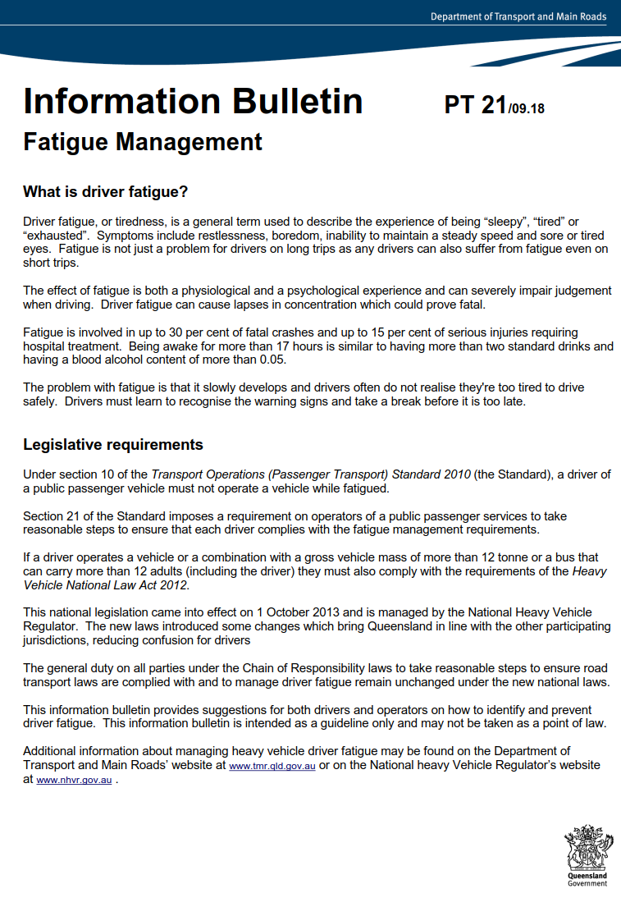

|  |
| --- |
| **Fatigue-regulated heavy vehicles**  National heavy vehicle driver fatigue laws apply to fatigue-regulated heavy vehicles, which are:     * A vehicle with a Gross Vehicle Mass (GVM) of over 12t * A combination when the total of the GVM is over 12t * Buses with a GVM over 4.5t fitted to carry more than 12 adults (including the driver) * A truck, or a combination including a truck, with a GVM of over 12t with a machine or implement attached |

**Useful links:-**

* Drivers Authorisation Card *-*  [https://www.tmr.qld.gov.au/Licensing/Passenger-transport-driverauthorisation.aspx](https://www.tmr.qld.gov.au/Licensing/Passenger-transport-driver-authorisation.aspx)
* National Driver Work Diary *-*<https://www.nhvr.gov.au/files/nhvr-national-driver-work-diary-08-2013.pdf>
* Supplementary Sheets-<https://www.nhvr.gov.au/files/201405-0028-supplementary-work-diary-record.pdf>
* Drivers - [https://www.nhvr.gov.au/safety-accreditation-compliance/fatigue-management/work-and-restrequirements/standard-hours](https://www.nhvr.gov.au/safety-accreditation-compliance/fatigue-management/work-and-rest-requirements/standard-hours)

**Contacts:**

If a hirer or driver are unsure of their legal obligations, please contact the following:-

1. Department of Transport & Main Roads – 13 23 80
2. National Heavy Vehicle Regulator - 1300 696 487