Muttaburra Town & Country Christmas Tree

Dear Parents,

The Muttaburra Town & Country Christmas Tree is upon us again.

This year is the **78th Christmas Tree** for the Muttaburra community.

**Where:** Jubilee Park (next to the pool) **When:** **11th December 2021 from 6pm**

**Dinner:** 7pm **Santa:** 7:30pm

**Conditions of receiving a present:**

* Your family must reside within a 65km radius of Muttaburra or use the town as a social/business centre.
* All children aged 14 years and under are entitled to receive a present. Parents are asked to make a donation of $15 towards each present.
* If completed forms are not returned and donation not made, then a present shall not be ordered by the committee and your child/children will miss out.
* Children that are not from the area and would like to receive a present from Santa can do so by their parents supplying a gift prior to the event so that they can join the fun.

**Please complete:**

|  |  |  |
| --- | --- | --- |
| **Name** | **Gender** | **Date of Birth** |
|  |  |  |
|  |  |  |
|  |  |  |
|  |  |  |
|  |  |  |
|  |  |  |

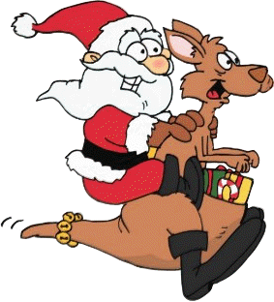

**Please return form and make donation by** **27th October 2021**

Email completed form to: [xmastreemuttaburra@gmail.com](mailto:xmastreemuttaburra@gmail.com)

Bank details:

A/c name: Muttaburra Town and Country Christmas Tree

BSB: 064 706 A/c number: 009 034 96

Reference: Family name Xmas – E.g. (Price Xmas)